Product Title | KuDoS – Hydraulic Battery Operated Tools
Product Tagline | Professional Electric & Electronic Tool hand Tools
Gambar Utama Produk | 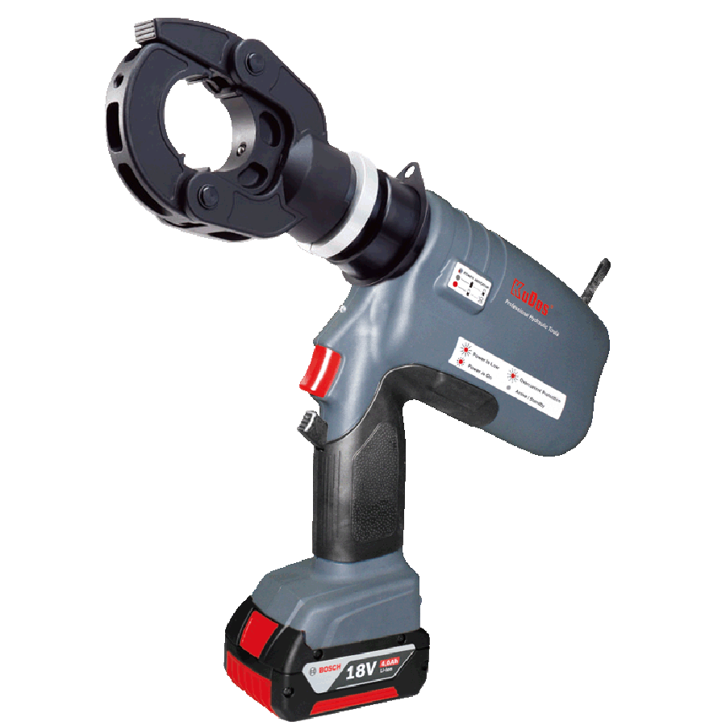
Product Brand | 
Overview Product | Hydraulic Battery operated Tools for Cutting, Crimping, Punching, Pipe Bending, Nut Splitting
PDF Brosur | https://www.dropbox.com/s/26q66z5g6fshcmu/KuDos_Catalogue.pdf?dl=0
Product Details | - Model No. K-50  Length : 427 mm  Weight : 3.3 kgs(w/o battery)  ■ Specifications :  Drive unit : 18V DC motor  Charger (GS/CE) :  Input voltage : 110V single phase AC  Input voltage : 230V single phase AC  Input frequency : 50~60 Hz  Reservoir capacity : 48 cc  ■ Crimping Capacity :  Max pressure : 520 bar  Max output : 5.53 tons / 49.2 kN  Crimping die sets as below (sold separately)  - Model No. K-150  Length : 328 mm  Weight : 2.0 kgs(w/o battery)  ■ Specifications :  Drive unit : 18V DC motor  Charger (GS/CE) :  Input voltage : 110V single phase AC  Input voltage : 230V single phase AC  Input frequency : 50~60 Hz  Reservoir capacity : 48 cc  ■ Crimping Capacity :  Max pressure : 420 bar  Max output : 4.73 tons / 42.1kN  Max compression : 150 mm² copper  Accepts BEKU type dies  Stock Dies are for DIN46235 terminals  ※Dies sold separately  - Model No. K-BGD3  Length : 459 mm  Weight : 3.1 kgs(w/o battery)  ■ Specifications :  Drive unit : 18V DC motor  Charger (GS/CE) :  Input voltage : 110V single phase AC  Input voltage : 230V single phase AC  Input frequency : 50~60 Hz  Reservoir capacity : 40 cc  ■ Crimping Capacity :  Max pressure : 460 bar  Max output : 6.0 tons / 58.0 kN  ■ Features :  Proper crimps are assured with butting steel jaws.  Increased strength and greater bearing area is provided with larger steel bolts.  Fast, easy, one-hand die insertion.  No lost dies with spring loaded positive lock die retainer buttons.  Full crimp force assured with over center cam action.  Operator protection provided with butt stops and heat shrinktubing.  Long life expectancy provided with fiberglass handles and light weight high strength aluminum alloy castings.  The “D3” groove accommodates the line of type “W”-die inserts.  ■ Connector range :  Copper, aluminum, ACSR, copperweld, alumoweld, steel, 6201, 5005, compressed and compact conductors.  Copper taps: # 10 sol.-2/0 str.  Aluminum, ACSR taps: # 14 sol.-4/0 ACSR  Stirrups: # 6 ACSR-4/0 ACSR  Overhead full tension deadend, full tension splices, non tension splices, and terminals conductor range: # 10 str.-4/0 ACSR  Code conductor connectors: # 6-4/0 str. Copper and aluminum  - Model No. K-10C  Length : 333 mm  Weight : 1.5 kgs(w/o battery)  ■ Specifications :  Drive unit : 18V DC motor  Charger (GS/CE) :  Input voltage : 110V single phase AC  Input voltage : 230V single phase AC  Input frequency : 50~60 Hz  Reservoir capacity : 40 cc  ■ Crimping Capacity :  Max pressure : 380 bar  Max output : 1.60 tons / 14.2 kN  - Model No. K-120  Length : 356 mm  Weight : 2.3 kgs(w/o battery)  ■ Specifications :  Drive unit : 18V DC motor  Charger (GS/CE) :  Input voltage : 110V single phase AC  Input voltage : 230V single phase AC  Input frequency : 50~60 Hz  Reservoir capacity : 40 cc  ■ Crimping Capacity :  Max pressure : 600 bar  Max output : 2.52 tons / 22.4N  Max compression : 16 mm² ~ 120 mm² copper  - Model No. K-185  Length : 360 mm  Weight : 2.2 kgs(w/o battery)  ■ Specifications :  Drive unit : 18V DC motor  Charger (GS/CE) :  Input voltage : 110V single phase AC  Input voltage : 230V single phase AC  Input frequency : 50~60 Hz  Reservoir capacity : 48 cc  ■ Crimping Capacity :  Max pressure : 460 bar  Max output : 5.77 tons / 51.3 kN  Max compression : 185 mm² copper  Accepts BEKU type dies  Stock Dies are for DIN46235 terminals  Dies sold separately (AHE1016/2535/5070/95120/150/185)  - Model No. K-240R  Length : 354 mm  Weight : 2.4 kgs(w/o battery)  ■ Specifications :  Drive unit : 18V DC motor  Charger (GS/CE) :  Input voltage : 110V single phase AC  Input voltage : 230V single phase AC  Input frequency : 50~60 Hz  Reservoir capacity : 48 cc  ■ Crimping Capacity :  Max pressure : 460 bar  Max output : 5.77 tons / 51.3 kN  Max compression : 240 mm² copper  Accepts BEKU type dies  Stock Dies are for DIN46235 terminals  ※Dies sold separately (AHE1016/2535/5070/95120/150/185)  - Model No. K-PH300  Length : 359 mm  Weight : 3.0 kgs(w/o battery)  ■ Specifications :  Drive unit : 18V DC motor  Charger (GS/CE) :  Input voltage : 110V single phase AC  Input voltage : 230V single phase AC  Input frequency : 50~60 Hz  Reservoir capacity : 48 cc  ■ Crimping Capacity :  Max pressure : 550 bar  Max output : 6.90 tons / 61.4 kN  Max compression : 300 mm² copper, aluminum lugs  Accepts all dies used for Alcoa, Burndy, T&B, Klauke, Cembre and Blackburn 6 ton compressors  ※Dies sold separately (T16/25/35/50/70/95/12/150/185/240/300)  - Model No. K-20  Length : 329 mm  Weight : 2.8 kgs(w/o battery)  ■ Specifications :  Drive unit : 18V DC motor  Charger (GS/CE) :  Input voltage : 110V single phase AC  Input voltage : 230V single phase AC  Input frequency : 50~60Hz  Reservoir capacity : 48 cc  ■ Cutting capacity:  Max pressure : 550 bar  Oil required : 24 cc  Max output : 5.85 tons / 52.0 kN  Wire rope 6x7 : 16 mm  Wire rope 6x12 : 20 mm  Wire rope 6x19 : 20 mm  Soft copper bar : 20 mm  Soft aluminum bar : 16 mm  Soft steel bar : 16 mm  Reinforcing rod : 13 mm  Cu strands : 20 mm  Al strands : 20 mm  ACSR : 21 mm  Guy wire 1x7 : 15 mm  Guy wire 1x19 : 16 mm  Underground cable : 18 mm  ※Cutting of piano wire is prohibited.  - Model No. K-24  For copper and aluminum cable up to 400 sq.mm. AWG 800 MCM.  Compound handles design, easy cutting.  Aluminum tube handles  Length: 700 mm  Weight: 1.57 kgs  - Model No. K-S24  Length : 356 mm  Weight : 3.8 kgs(w/o battery)  ■ Specifications :  Drive unit : 18V DC motor  Charger (GS/CE) :  Input voltage : 110V single phase AC  Input voltage : 230V single phase AC  Input frequency : 50~60Hz  Reservoir capacity : 48 cc  ■ Cutting capacity :  Max pressure : 700 bar  Oil required : 31 cc  Max output : 8.78 tons / 78.1 kN  Wire rope 6x7 : 18 mm  Wire rope 6x12 : 24 mm  Wire rope 6x19 : 24 mm  Soft steel bar : 20 mm  Reinforcing rod : 16 mm  Cu strands : 24 mm  Al strands : 24 mm  ACSR cable : 24 mm  Guy wire 1x7 : 20 mm  Guy wire 1x19 : 20 mm  ※Cutting of piano wire is prohibited.  - Model No. K-30A  Length : 412 mm  Weight : 3.7 kgs(w/o battery)  ■ Specifications :  Drive unit : 18V DC motor  Charger (GS/CE) :  Input voltage : 110V single phase AC  Input voltage : 230V single phase AC  Input frequency : 50~60Hz  Reservoir capacity : 48 cc  ■ Cutting capacity :  Max pressure : 700 bar  Max output : 8.78 tons / 78.1 kN  Cu strands : 28 mm  Al strands : 28 mm  ACSR : 19 mm  Telephone cable : 30 mm  CCP cable : 30 mm  Underground cable : 30 mm  ※Cutting of piano wire is prohibited.  - Model No. LEC-185T  Length : 310 mm  Weight : 3.9 kgs (w/o battery)  ■ Specifications :  Drive unit : 18V DC motor  Charger (GS/CE) :  Input voltage : 110V single phase AC  Input voltage : 230V single phase AC  Input frequency : 50~60Hz  Input current : 21.75VA  Reservoir capacity : 120 cc  ■ Crimp capacity :  Max pressure : 460 bar  Max output : 5.77 tons / 51.3 kN  Max compression : 185 mm²  Accepts BEKU type dies  Stock dies are for DIN46235 terminals  ※Dies sold separately(AHE 1016/2535/5070/95120/150/185)  - Model No. LEC-240TR  Height : 360 mm  Weight : 4.1 kgs (w/o battery)  ■ Specifications :  Drive unit : 18V DC motor  Charger (GS/CE) :  Input voltage : 110V single phase AC  Input voltage : 230V single phase AC  Input frequency : 50~60Hz  Input current : 21.75 VA  Reservoir capacity : 120 cc  ■ Crimp capacity :  Max pressure : 550 bar  Max output : 6.90 tons / 61.4 kN  Max compression : 240 mm²  Accepts BEKU type dies  Stock dies are for DIN46235 terminals  ※Dies sold separately(AHE 1016/2535/5070/95120/150/185/240)  - Model No. LEC-U27  Height : 323 mm  Weight : 6.1 kgs (w/o battery)  ■ Specifications :  Drive unit : 18V DC motor  Charger (GS/CE) :  Input voltage : 110V single phase AC  Input voltage : 230V single phase AC  Input frequency : 50~60Hz  Input current : 21.75 VA  Reservoir capacity : 120 cc  ■ Crimp capacity :  U-type head  Crimping force : 14.01 tons / 124.6 kN  Main applications :  L.V. lugs & splices : 400 mm²  Insulated terminals : 240 mm²  C sleeve connector : 185 mm²  H.V. lugs & splices : 400 mm²  Al lugs & splices : 300 mm²  ※Dies sold separately  - Model No. LEC-150  Length : 354 mm  Weight : 4.7 kgs (w/o battery)  ■ Specifications :  Drive unit : 18V DC motor  Charger (GS/CE) :  Input voltage : 110V single phase AC  Input voltage : 230V single phase AC  Input frequency : 50~60Hz  Input current : 21.75VA  Reservoir capacity : 120 cc  ■ Crimp capacity :  Max pressure : 700 bar  Oil requires : 31 cc  Crimping force : 14.01 tons / 124.6 kN  Main application : up to 150mm² CU  - Model No. LEC-32T  Height : 385 mm  Weight : 6.0 kgs (w/o battery)  ■ Specifications :  Drive unit : 18V DC motor  Charger (GS/CE) :  Input voltage : 110V single phase AC  Input voltage : 230V single phase AC  Input frequency : 50~60Hz  Input current : 21.75VA  Reservoir capacity : 120 cc  ※Insulated cap should be ordered separately  ■ Crimp capacity :  Jaw opening : 32 mm  Crimping force : 14.01 tons / 124.6 kN  Main application : up to 400mm² CU  ※Dies sold separately  Accepts all dies used by Alcoa, Burndy, T&B, Klauke, Cembre and Blackburn 12 ton U-type dies.  Suitable for terminals with wall thickness little less than DIN 46235 cable lugs.  - Model No. LEC-40T  Height : 389 mm  Weight : 6.0 kgs (w/o battery)  ■ Specifications :  Drive unit : 18V DC motor  Charger (GS/CE) :  Input voltage : 110V single phase AC  Input voltage : 230V single phase AC  Input frequency : 50~60Hz  Input current : 21.75 VA  Reservoir capacity : 120 cc  ■ Crimp capacity :  Jaw opening : 40 mm  Crimping force : 14.01 tons / 124.6 kN  Main application : up to 400mm² CU  ※Dies sold separately  Accepts all dies used by Alcoa, Burndy, T&B, Klauke, Cembre and Blackburn 12 ton U-type dies.  Suitable for terminals with wall thickness little less than DIN 46235 cable lugs.  - Model No. LEC-44T  Height : 363 mm  Weight : 6.7 kgs (w/o battery)  ■ Specifications :  Drive unit : 18V DC motor  Charger (GS/CE) :  Input voltage : 110V single phase AC  Input voltage : 230V single phase AC  Input frequency : 50~60Hz  Input current : 21.75 VA  Reservoir capacity : 120 cc  ※insulated cap should be ordered separately  ■ Crimp capacity :  Jaw opening : 44 mm  Crimping force : 14.01 tons / 124.6 kN  Main application : up to 400mm² CU  ※Dies sold separately  Accepts all dies used by Alcoa, Burndy, T&B, Klauke, Cembre and Blackburn 12 ton U-type dies.  Suitable for terminals with wall thickness little less than DIN 46235 cable lugs.  - Model No. LEC-300  Height : 327 mm  Weight : 4.6 kgs (w/o battery)  ■ Specifications :  Drive unit : 18V DC motor  Charger (GS/CE) :  Input voltage : 110V single phase AC  Input voltage : 230V single phase AC  Input frequency : 50~60Hz  Input current : 21.75 VA  Reservoir capacity : 120 cc  ■ Crimp capacity :  Max pressure : 550 bar  Max compression : 300 mm²  Crimping force : 6.90 tons / 61.4 kN  ※Dies sold separately(T16/25/35/50/70/95/120/150/185/240/300)  - Model No. LEC-S55  Length : 479 mm  Weight : 8.4 kgs (w/o battery)  ■ Specifications :  Drive unit : 18V DC motor  Charger (GS/CE) :  Input voltage : 110V single phase AC  Input voltage : 230V single phase AC  Input frequency : 50~60Hz  Input current : 21.75 VA  Reservoir capacity : 120 cc  ■ Cutting capacity :  Max pressure : 700 bar  Oil required : 106.6 cc  Max output : 14.01 tons / 124.6 kN  Wire rope 6x7 : 25 mm  Wire rope 6x12 : 30 mm  Wire rope 6x19 : 30 mm  Soft copper bar : 35 mm  Soft aluminum bar : 28 mm  Soft steel bar : 22 mm  Reinforcing rod : 19 mm  Cu strands : 54 mm  Al strands : 54 mm  ACSR : 54 mm  Guy wire 1x7 : 15 mm  Guy wire 1x19 : 20 mm  Underground cable : 50 mm  ※Cutting of piano wire is prohibited.  - Model No. LEC-C85  Hegiht : 345 mm  Weight : 7.2 kgs (w/o battery)  ■ Specifications :  Drive unit : 18V DC motor  Charger (GS/CE) :  Input voltage : 110V single phase AC  Input voltage : 230V single phase AC  Input frequency : 50~60Hz  Input current : 21.75 VA  Reservoir capacity : 120 cc  ■ Cutting capacity :  Max pressure : 700 bar  Oil required : 75 cc  Max output : 6.23 tons / 55.4 kN  Material : copper and aluminum cables  Maximum size : Ø85 mm  ※Cutting of piano wire is prohibited.  - Model No. LEC-065  Length : 524 mm  Weight : 7.1 kgs (w/o battery)  ■ Specifications :  Drive unit : 14.4V DC motor  Charger (GS/CE) :  Input voltage : 110V single phase AC  Input voltage : 230V single phase AC  Input frequency : 50~60Hz  Input current : 21.75 VA  Reservoir capacity : 120 cc  ■ Cutting capacity :  Max pressure : 700 bar  Max output : 8.78 tons / 78.1 kN  Cu strands : 60 mm  Al strands : 60 mm  CCP cable : 65 mm  Underground cable : 65mm(Except armoured cable)  ※ Cutting of piano wire is prohibited.  - Model No. LEC-85YC  Length : 516 mm  Weight : 7.1 kgs (w/o battery)  ■ Specifications :  Drive unit : 18V DC motor  Charger (GS/CE) :  Input voltage : 110V single phase AC  Input voltage : 230V single phase AC  Input frequency : 50~60Hz  Input current : 21.75 VA  Reservoir capacity : 120 cc  ■ Cutting capacity :  Max pressure : 700 bar  Max output : 8.78 tons / 78.1 kN  Cu strands : 60 mm  Al strands : 60 mm  CCP cable : 85 mm  ※Note : tensile strength(daN/mm²) ≦ 180  ※Cutting of piano wire is prohibited.
Key Features | Battery Operated Tools
Galeri Produk | TERLAMPIR

