Product Title | KuDoS – Bus Bar Cutter & Benders
Product Tagline | Professional Electric & Electronic Tool hand Tools
Gambar Utama Produk | 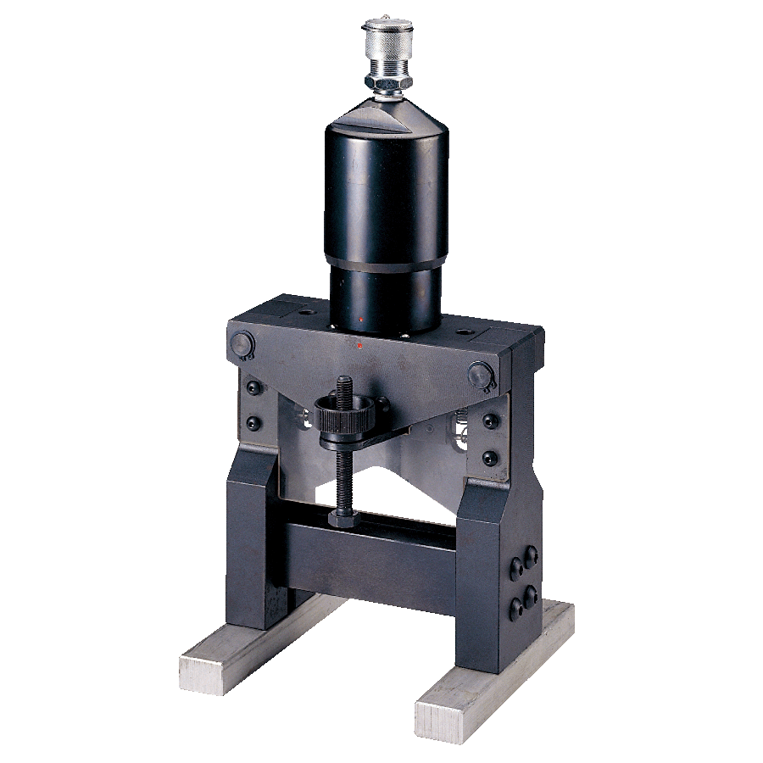
Product Brand | 
Overview Product | Hydraulic Bus Bar Cutter & Benders for Aluminium, Copper and Iron Materials
PDF Brosur | https://www.dropbox.com/s/26q66z5g6fshcmu/KuDos_Catalogue.pdf?dl=0
Product Details | - Model No. HYBC-120  Height : 410 mm  Weight : 14.8 kgs  ■ Specifications :  Max. Pressure : 700 bar  Oil Required : 131 cc  Max. Output : 24.13 tons / 214.7 kN  ■ Cutting capacity :  Max. Width : 120 mm  Max. Thickness : 12 mm  Suitable Materials : aluminum, copper, iron  ■ Features :  Vertical stand ideally suited for cutting solid copper and aluminum bus bars.  Level and precise cut.  Great cutting capacity.  Single action cylinder can be uncoupled from the cutting capacity.  The cylinder can also be connected to our bus bar bending model HYBN-120.  Operated by any hydraulic pump with rated oil pressure of 700 bar (10,000 psi).  - Model No. ASC-7510  Height : 425 mm  Weight : 22.0 kgs  ■ Specifications :  Max. Pressure : 700 bar  Oil Required : 353 cc  Max. Output : 43.93 tons / 390.8 kN  ■ Cutting Capacity :  Max. Width : 75 mm  Max. Thickness : 9 mm  Suitable Materials : stainless steel, iron  ■ Features :  Vertical stand ideally suited for cutting angled stainless steel.  Level and precise cut.  Great cutting capacity.  Single action cylinder can be uncoupled from the cutting unit.  Operated by any hydraulic pump with rated oil pressure of 700 bar (10,000 psi).  - Model No. HYBN-120  Height : 360 mm  Weight : 15.2 kgs  ■ Specifications :  Max. Pressure : 700 bar  Oil Required : 124 cc  Max. Output : 24.13 tons / 214.7 kN  Effective Stroke : 130 mm  ■ Bending Capacity :  Max. Width : 120 mm  Max. Angle : 90 degree  Max. Thickness : 12 mm  Suitable Materials : aluminum, copper  ■ Features :  Vertical stand ideally suited for bending solid copper and aluminum bus bars.  2 lateral parallel-stops for exact angular positioning of bus bars.  Convenient scale for reading the current bending angle.  Single action cylinder can be uncoupled from the bending unit.  The cylinder can also be connected to our bus bar cutting model HYBC-120.  Operated by any hydraulic pump with rated oil pressure of 700 bar (10,000 psi).  - Model No. HYBN-160  Height : 360 mm  Weight : 18.2 kgs  ■ Specifications :  Max. Pressure : 700 bar  Oil Required : 130 cc  Max. Output : 24.13 tons / 214.7 kN  Effective Stroke : 160 mm  ■ Bending capacity :  Max. Width : 160 mm  Max. Angle : 90 degree  Max. Thickness : 12 mm  Suitable Materials : aluminum, copper  ■ Features :  Vertical stand ideally suited for bending solid copper and aluminum bus bars.  2 lateral parallel-stops for exact angular positioning of bus bars.  Convenient scale for reading the current bending angle.  Single action cylinder can be uncoupled from the bending unit.  The cylinder can also be connected to our bus bar cutting model HYBC-160. Operated by any hydraulic pump with rated oil pressure of 700 bar (10,000 psi).
Key Features | Hydraulic Bus Bar Cutter and Benders
Galeri Produk | TERLAMPIR

