Product Title | KuDoS – Hand Tools – Cable Cutters
Product Tagline | Professional Electric & Electronic Tool hand Tools
Gambar Utama Produk | 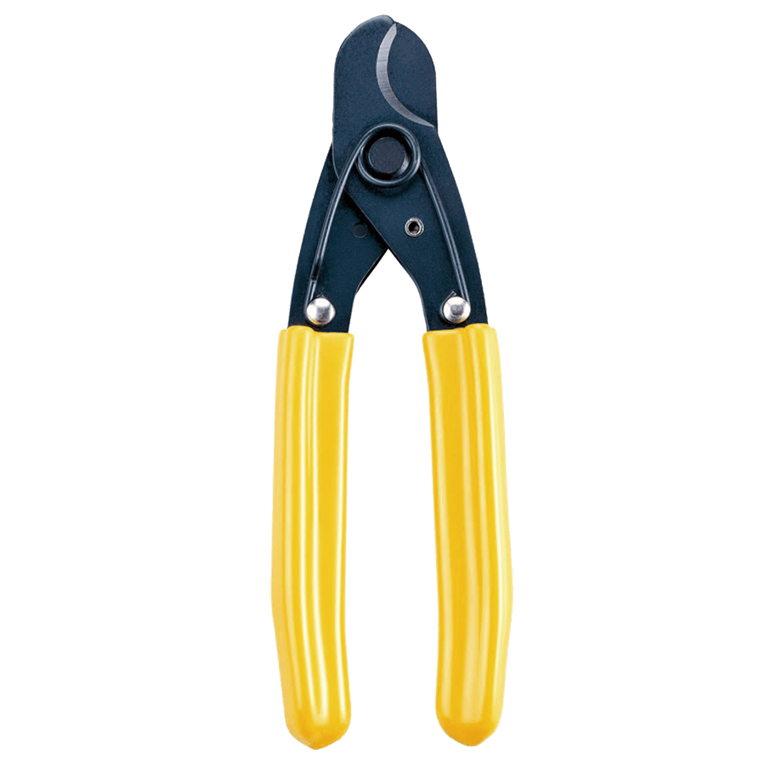
Product Brand | 
Overview Product | Cable Cutters for cut Round Cable, Wire Multi-Conductor, Copper and Aluminium Cable up to 500 sq.mm.AWG 1000 MCM
PDF Brosur | https://www.dropbox.com/s/26q66z5g6fshcmu/KuDos_Catalogue.pdf?dl=0
Product Details | - Model No. CC-08  Cut round cable and wire multi-conductor  Cable up to .500", coaxial cable up to RG-9/U, stranded wire up to 10 sq.mm. #8 AWG.  Length: 165 mm  Weight: 0.15 kgs  - Model No. CC-22  For copper and aluminum cable up to 25 sq.mm. #4 AWG.  Length: 165 mm  Weight: 0.19 kgs  - Model No. CC-38S  For copper and aluminum cable up to 38 sq.mm. #2 AWG.  Length: 210 mm  Weight: 0.30 kgs  - Model No. CC-38  For copper and aluminum cable up to 38 sq.mm. #2 AWG.  Length: 210 mm  Weight: 0.30 kgs  - Model No.CC-60  For copper and aluminum cable up to 60 sq.mm. AWG 1/0.  Length: 235 mm  Weight: 0.38 kgs  - Model No. CC-80  For copper and aluminum cable up to 80 sq.mm. AWG 3/0  Length: 320 mm  Weight: 0.73 kgs  - Model No. CC-250  For copper and aluminum cable up to 250 sq.mm. AWG 500 MCM.  Length: 600 mm  Weight: 1.54 kgs  - Model No. CC-500  For copper and aluminum cable up to 500 sq.mm. AWG 1000 MCM.  Length: 800 mm  Weight: 2.93 kgs  - Model No. CC-185  For copper and aluminum cable up to 185 sq.mm. AWG 350 MCM.  Compound handles design, easy cutting.  Length: 600 mm  Weight: 1.80 kgs  - Model No. CC-400LT  For copper and aluminum cable up to 400 sq.mm. AWG 800 MCM.  Compound handles design, easy cutting.  Aluminum tube handles  Length: 700 mm  Weight: 1.57 kgs
Key Features | Cable Cutters
Galeri Produk | 