Product Title | KuDoS – Hydraulic Crimpers
Product Tagline | Professional Electric & Electronic Tool hand Tools
Gambar Utama Produk | 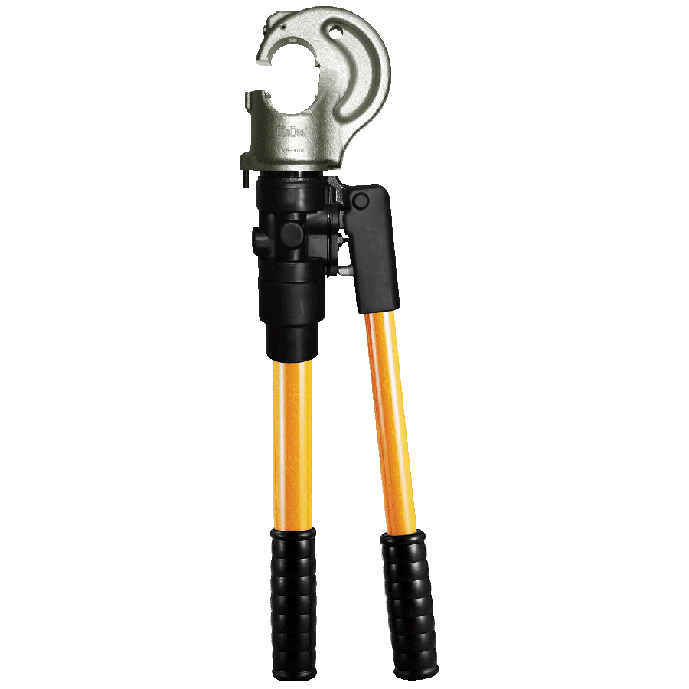
Product Brand | 
Overview Product | Hydraulic Crimping Tools for Steel, Copper and Aluminium Lugs / Conductors
PDF Brosur | https://www.dropbox.com/s/26q66z5g6fshcmu/KuDos_Catalogue.pdf?dl=0
Product Details | - Model No. HH-400  Length : 559 mm  Weight : 5.8 kgs (Dies not included)  ■ Specifications :  Max. Pressure : 700 bar  Oil Required : 57 cc  Max. Output : 15.82 tons / 140.7 kN  ■ Features :  Light weight, compact and slim design.  Single stage pumping for rapid ram advance.  Relief valve.  Head rotates through 180° for difficult working environment.  ■ Accessories :  Plastic carrying case  ※Crimping tope only without any die set.  ※Dies sold separately  - Model No. 9H-150  Length : 528 mm  Weight : 5.0 kgs  ■ Specifications :  Max. Pressure : 700 bar  Oil Required : 31 cc  Max. Output : 14.01 tons / 124.6 kN  ■ Crimping Capacity :  For non-Insulated terminals and sleeves up to 150 mm²  With Indentor 14, 22, 38~70 and 80~150 mm²  ■ Features :  Light weight, compact and slim design.  Rotary nest for easy setting.  Two stage pumping for rapid ram advance.  Relief valve.  ■ Accessories :  Plastic carrying case  - Model No. HYCP-185  Length : 373 mm  Weight : 2.1 kgs  ■ Specifications :  Max. Pressure : 550 bar  Oil Required : 16 cc  Max. Output : 5.85 tons / 52.0 kN  Crimping Capacity  Accepts BEKU type dies  Stock Dies are for DIN 46235 terminals  ※Dies sold separately (AHE-1016/2535/5070/95120/150/185)  ■ Features :  Light weight, compact and slim design.  Single action cylinder with spring return.  Accepts BEKU type dies.  Yoke and Latch type head for easy die changes and removal of connectors.  Adjustable ram stroke, 10-15 mm to minimize pumping action.  Built-ln bypass relief valve.  Small handle spread for close quarter applications.  ■ Accessories :  Plastic carrying case  - Model No. UC-6  Length : 627 mm  Weight : 6.0 kgs  ■ Specifications :  Max. Pressure : 700 bar  Oil Required : 27 cc  Max. Output : 7.03 tons / 62.5 kN  Jaw Opening : 29 mm  Max. Crimping Capacity: up to 32 mm outer diameter connector (UC-6)  ■ Features :  Light weight, compact and slim design.  Pressure relief valve for overload protection.  Automatic low/high-pressure conversion with rapid/slow operating motion.  360° rotating head for convenient operation.  Two-stage hydraulic system reduces the number of pumps required.  Dieless compression to crimp Anderson style connectors up to 500 MCM.  ■ Accessories :  Plastic carrying case  - Model No. UB-400  Height : 598 mm  Weight : 6.8 kgs  ■ Specifications :  Max. Pressure : 700 bar  Oil Required : 48 cc  Max. Output : 14.01 tons / 124.6 kN  Jaw Opening : 26 mm  ■ Crimping Capacity :  Max. Compression : 400mm² copper / aluminum lugs.  Accepts all dies used for Alcoa, Burndy, T&B, Klauke, Cembreand Blackburn 6 tons compressors.  ※Dies sold separately(CU16/25/35/50/70/95/120/150/185/240/300/400)  ■ Features :  330° rotating head for convenient operation.  Fiberglass handles are durable and light weight.  External adjustable relief valve.  Pressure relief valve for overload protection.  Automatic low/high-pressure conversion with rapid/slow operating motion.  Two-stage hydraulic system reduces the number of pumps required.  ■ Accessories :  Plastic carrying case  - Model No. UB-412T  Length : 630 mm  Weight : 6.4 kgs  ■ Specifications :  Max. Pressure : 700 bar  Oil Required : 53 cc  Max. Output : 12.87 tons / 114.5 kN  Jaw opening : 32 mm  ■ Crimping Capacity :  Max. Compression : 400mm² copper lugs  Accepts all dies used for Alcoa, Burndy, T&B, Klauke, Cembreand Blackburn 6 tons compressors.  ※Dies sold separately(CU16/25/35/50/70/95/120/150/185/240/300/400)  ■ Features :  180° rotating head for convenient operation.  Fiberglass handles are durable and light weight.  External adjustable relief valve.  Pressure relief valve for overload protection.  Automatic low/high-pressure conversion with rapid/slow operating motion.  Two-stage hydraulic system reduces the number of pumps required.  ■ Accessories :  Plastic carrying case
Key Features | Hydraulic Crimpers
Galeri Produk | TERLAMPIR

