Product Title | KuDoS – Hydraulic Crimping Heads
Product Tagline | Professional Electric & Electronic Tool hand Tools
Gambar Utama Produk | 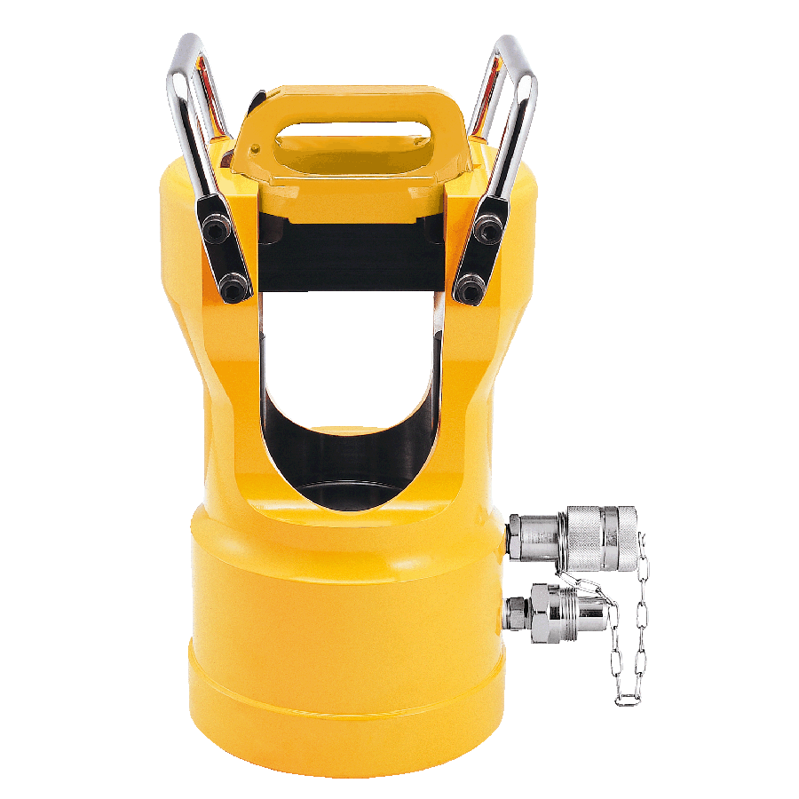
Product Brand | 
Overview Product | Hydraulic Crimping Equipment for Steel, Copper and Aluminium Lugs / Conductors
PDF Brosur | https://www.dropbox.com/s/26q66z5g6fshcmu/KuDos_Catalogue.pdf?dl=0
Product Details | - Model No. 9H-150HE  Length : 246 mm  Weight : 2.7 kgs  ■ Specifications :  Max. Pressure : 700 bar  Oil Required : 31 cc  Max. Output : 14.01 tons / 124.6 kN  ■ Crimping Capacity :  For non-insulated terminals and sleeves up to 150 mm²  With indentors 14, 22, 38~70 and 80~150 mm²  ■ Features :  Light weight, compact and slim design.  Rotary nest for easy setting.  Operated by are hydraulic pump with rated oil pressure of 700 bar (10,000 psi).  ■ Accessories :  Plastic carrying case  - Model No. UCP-240HE  Length : 213 mm  Weight : 2.4 kgs  ■ Specifications :  Max. Pressure : 700 bar  Oil Required : 24 cc  Max. Output : 9.73 tons / 86.6 kN  ■ Crimping Capacity :  Accepts BEKU type dies  Hex. Crimping : 10-240 mm²  Cu sleeves&lugs NFC 20.130:20 to 240 mm²  Cu or Al bare or insulated sleeve : E54 to E230  Cu or Al sleeves&lugs DIN 48083 : KZ6 to KZ25  Pre-rounding : 35 to 240 mm  ※Dies sold separately  ■ Features :  Light weight, compact and slim design.  Operated by are hydraulic pump with rated oil pressure of 700 bar (10,000 psi).  ■ Accessories :  Plastic carrying case  - Model No. UB-400HE  Length : 260 mm  Weight : 4.2 kgs  ■ Specifications :  Max. Pressure : 700 bar  Oil Required : 47 cc  Max. Output : 14.01 tons / 124.6 kN  Jaw Opening : 26 mm  ■ Crimping Capacity :  Max. compression: 400 mm² copper lugs  Accepts all dies used for Alcoa, Burndy, T&B, Klauke, Combre and Blackburn 12-ton compressors  ※Dies sold separately(CU16/25/35/50/70/95/120/150/185/240/300/400)  ■ Features :  C-frame has open jaw for easy access to the fitting.  Operated by are hydraulic pump with rated oil pressure of 700 bar (10,000 psi).  Single action cylinder with spring return.  Dies are easy to change.  Crimping capacity identical to UB-400 tool.  ■ Accessories :  Plastic carrying case  - Model No. UB-412THE  Length : 261 mm  Weight : 4.2 kgs  ■ Specifications :  Max. Pressure : 700 bar  Oil Required : 53 cc  Max. Output : 14.01 tons / 124.6 kN  Jaw Opening : 32 mm  ■ Crimping Capacity :  Max. compression : 400 mm² copper lugs  Accepts all dies used for Alcoa, Burndy, T&B, Klauke, Combre and Blackburn 12-ton compressors  ※Dies sold separately(CU16/25/35/50/70/95/120/150/185/240/300/400)  ■ Features :  C-frame has open jaw for easy access to the fitting.  Operated by any hydraulic pump with rated oil pressure of 700 bar (10,000 psi ).  Single action cylinder with spring return.  Dies are easy to change.  Crimping capacity identical to UB-412T tool.  ■ Accessories :  Plastic carrying case  - Model No. UC-6HE  Length : 278 mm  Weight : 3.2 kgs  ■ Specifications :  Max. Pressure : 700 bar  Oil Required : 27 cc  Max. Output : 7.03 tons / 62.5 kN  Max. Crimping capacity : up to 32 mm outer diameter connector(UC-6)  ■ Features :  Light weight, compact and slim design.  Operated by any hydraulic pump with rated oil pressure of 700 bar(10,000 psi).  Dieless compression to crimp Anderson style connectors up to 500 MCM.  ■ Accessories :  Plastic carrying case  - Model No. HYCP-451000HE  Length : 258 mm  Weight : 11.6 kgs  ■ Specifications :  Max. Pressure : 700 bar  Oil Required : 226 cc  Max. Output : 49.25 tons / 438.1 kN  Ram Stroke : 35.5 mm  ■ Crimping Capacity :  Max. crimping capacity: 1000 mm²  Customized die sets can be ordered  CU 400/500/630/800/1000 sold separately  ■ Features :  U-type head design is solid and durable  Lock pin design holds die firmly in place.  Operated by any hydraulic pump with rated oil pressure of 700 bar (10,000 psi).  Single action cylinder with spring return.  ■ Accessories :  Plastic carrying case  ■ Model No . ADP-451000HE  This adapter is designed for hydraulic  compression head HYCP-451000HE /  HYCP-451000D to interchange with 12-ton  (up to 400 mm²)  - Model No. HYCP-60D  Length : 446 mm  Weight : 23.3 kgs  ■ Specifications :  Max. Pressure : 700 bar  Oil Required : 298 cc  Max. Output : 60.81 tons / 541.0 Kn  Ram Stroke : 38 mm  ■ Crimping Capacity :  Crimping range : up 60 mm O.D.sleeve  Accepts all dies used for Alcoa, 60 ton compressors  Double-acting hydraulic pump required  ※Dies are manufactured on request only  ■ Features :  Solid metal loop at base for hoist work.  Ram retracts hydraulically; the ram retracting time is 1/3 of spring return.  Operated by any double-acting hydraulic pump with rated oil pressure of 700 bar (10,000 psi).  Detachable ground stand as a standard accessory.  Large handle for easy carrying.  Compression head is designed as a portable tool for installing compression sleeves and terminals for transmission construction and/or maintenance work.  ■ Accessories :  Metal case  - Model No. SR-100C  Length : 364 mm  Weight : 31.4 kgs  ■ Specifications :  Max. Pressure : 700 bar  Oil Required : 318 cc  Max. Output : 110.82 tons / 985.9 Kn  Ram Stroke : 22 mm  ■ Crimping Capacity :  Crimping range :  Copper : up to 64 mm O.D.sleeve  Aluminum : up to 71 mm O.D.sleeve  Steel : up to 32 mm O.D.sleeve  ※Double-acting hydraulic pump required  ※Dies are manufactured on request only  ■ Features :  Operated by any hydraulic pump with rated oil pressure of 700 bar (10,000 psi).  Functional handles for easy carrying and repositioning.  Removable die cap for easy connector positioning.  Ram retracts hydraulically ; the ram retracting time is 1/3 of spring return.  Compression head is designed as a portable tool for installing compression sleeves and terminals for transmission construction and/or maintenance work.  - Model No. 200W  Length : 445 mm  Weight : 78.0 kgs  ■ Specifications :  Max. Pressure : 700 bar  Oil required : 1049 cc  Max. output : 219.51 tons / 1952.9 kN  Ram stroke : 37 mm  ■ Crimping Capacity :  Crimping range :  Copper : up to 86 mm O.D.sleeve  Aluminum : up to 100 mm O.D.sleeve  Steel : up to 50 mm O.D.sleeve  ※Double-acting hydraulic pump required  ※Dies are manufactured on request only or current die set available sold separately  ■ Features :  Operated by any hydraulic pump with rated oil pressure of 700 bar (10,000 psi).  Functional handles for easy carrying and repositioning.  Removable die cap for easy connector positioning.  Ram retracts hydraulically ; the ram retracting time is 1/3 of spring return.  Compression head is designed as a portable tool for installing compression sleeves and terminals for transmission construction and/or maintenance work.  - Model No. SR-300CX  Length : 682 mm  Weight : 182.0 kgs  ■ Specifications :  Max. Pressure : 700 bar  Oil Required : 3340 cc  Max. Output : 350.24 tons / 3115.9 kN  Ram Stroke : 43.7 mm  ■ Crimping Capacity :  Maximum compressible sleeve diameter : 150mm  ※Double-Acting hydraulic pump required.  ※Dies are manufactured on request only.  ■ Features :  Operated by any double-acting hydraulic pump with rated oil pressure of 700 bar (10,000 psi).  Functional handles for easy carrying and repositioning.  Removable die cap for easy connector positioning.  Ram retracts hydraulically; the ram retracting time is 1/3 of spring return.  Compression head is designed as a portable tool for installing compression sleeves and terminals for transmission construction and / or maintenance work.  ※ Crimping without die sets is prohibited.
Key Features | Hydraulic Crimping Heads
Galeri Produk | TERLAMPIR

