Product Title | KuDoS – Hydraulic Nut Splitters
Product Tagline | Professional Electric & Electronic Tool hand Tools
Gambar Utama Produk | 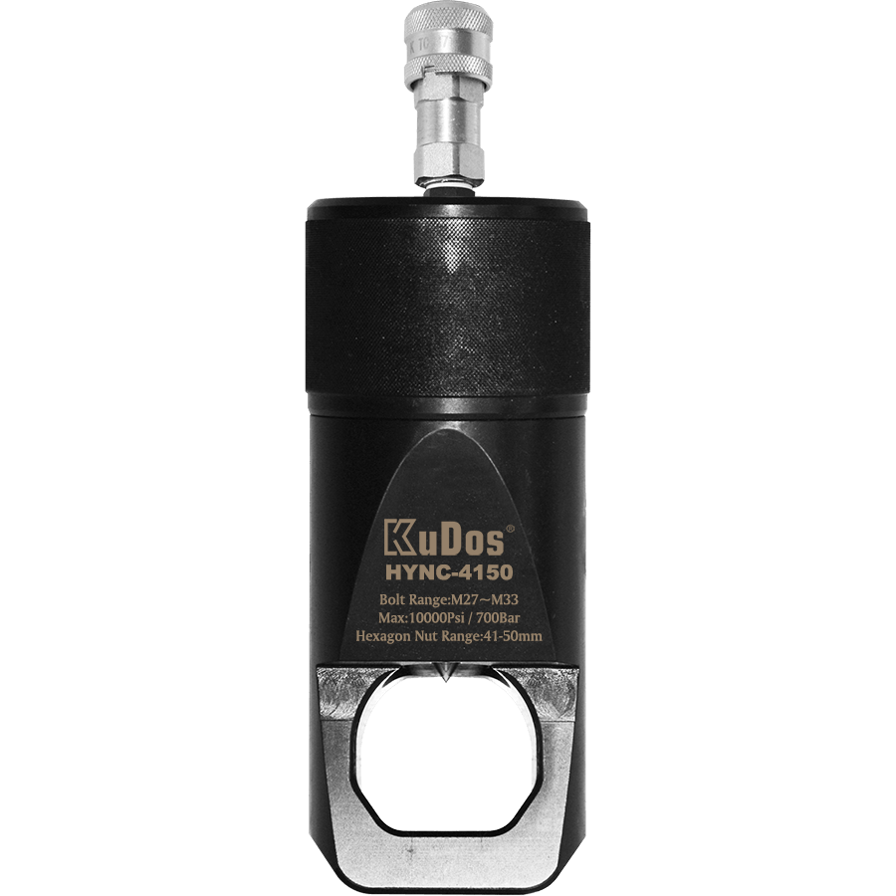
Product Brand | 
Overview Product | Hydraulic Nut Spliter suitable for hexagonal grade 8 nuts
PDF Brosur | https://www.dropbox.com/s/26q66z5g6fshcmu/KuDos_Catalogue.pdf?dl=0
Product Details | - Model No. PF-1319  Length : 333 mm  Weight : 2.1 kgs  ■ Specifications :  Max. Pressure : 600 bar  Oil Required : 17 cc  Max. Output : 7.45 ton / 66.3 Kn  Bolting Range : M6~M12  (Hex. Nut range : 10-19 mm)  ■ Bolting Capacity :  Jaw opening : 24.3 mm  Ram Stroke : 17.3 mm  ■ Features :  Light weight, compact and slim design.  180° degree rotating head for convenient operation.  Single stage pumping.  Relief valve.  ■ Accessories :  Carrying Bag  ※Caution :  Only suitable for ≤ grade 8 nuts, splitting of stainless, square, and / or star nuts are prohibited.  Nut hardness must not exceed HRc-44.  - Model No. HYNC-4510  HYNC-series (Single blade)  ■ Features :  Compact design.  Easy to use.  Seven models of nut splitter to choose from.  Unique angled head design for a variety of applications.  Single action cylinder with hydraulic advance with spring-return.  Operated by hydraulic pump with rated oil pressure of 700 bar(10,000psi).  Specifications : Single blade type  Model No Bolt Range Hex Nut Range (mm) Capacity (ton) Oil Capacity(cm³) Dimensions(mm) Net Weight(kg) Gross Weight(kg)  Length Width Height  HYNC-1319 M6-M12 10-19 6.23 15 170 40 48 1.2 2.6  HYNC-1924 M12-M16 19-24 11.24 20 191 54 62 2.0 3.6  HYNC-2432 M16-M22 24-32 18.39 60 222 64 72 3.0 5.2  HYNC-3241 M22-M27 32-41 25.69 80 244 75 88 4.4 7.0  HYNC-4150 M27-M33 41-50 38.92 155 288 94 105 8.2 13.6  HYNC-5060 M33-M39 50-60 54.88 240 318 106 128 11.8 18.4  HYNC-6075 M39-M48 60-75 102.76 492 393 156 181 34.1 42.7  Model No A B C D E F G Spare Chisels No.  HYNC-1319 40 21 7 19 50 29 120 HYNC-1319#4 Chisels  HYNC-1924 54 25 10 25 62 40 146 HYNC-1924#4 Chisels  HYNC-2432 64 33 13 30 76 52 180 HYNC-2432#4 Chisels  HYNC-3241 70 42 16 36 87 65 205 HYNC-3241#4 Chisels  HYNC-4150 90 52 21 45 108 76 245 HYNC-4150#4 Chisels  HYNC-5060 106 60 24 54 125 92 288 HYNC-5060#4 Chisels  HYNC-6075 156 80 27 75 184 110 365 HYNC-6075#4 Chisels  ※Caution :  Only suitable for ≤ grade 8 nuts, splitting of stainless, square, and / or star nuts are prohibited.  Nut hardness must not exceed HRc-44.  ■ Accessories :  Model No. Hex Wench(mm) Packaging  HYNC-1319 2.5 & 4 KuDos ® Plastic Carrying Case  HYNC-1924 3 & 5  HYNC-2432 3 & 5  HYNC-3241 4 & 6  HYNC-4150 4 & 6  HYNC-5060 5 & 6  HYNC-6075 5 & 6 Crate  - Model No. HYNC-4150D  HYNC-series (Double blade)  ■ Features :  Compact design.  Easy to use.  Seven models of nut splitter to choose from.  Unique angled head design for a variety of applications.  Single action cylinder with hydraulic advance with spring-return.  Operated by hydraulic pump with rated oil pressure of 700 bar(10,000psi).  Specifications : Double blade  Model No Bolt Range Hex Nut Range (mm) Capacity (ton) Oil Capacity(cm³) Dimensions(mm) Net Weight(kg) Gross Weight(kg)  Length Width Height  HYNC-1319D M6-M12 10-19 6.23 15 223 44 67 1.3 2.8  HYNC-1924D M12-M16 19-24 11.77 20 250 56 74 2.4 3.8  HYNC-2432D M16-M22 24-32 19.07 60 275 64 78 3.5 5.4  HYNC-3241D M22-M27 32-41 26.49 80 305 77 90 5.1 7.2  HYNC-4150D M27-M33 41-50 38.92 155 344 97 111 9.7 13.8  HYNC-5060D M33-M39 50-60 56.04 240 386 115 131 14.7 18.6  HYNC-6075D M39-M48 60-75 102.76 492 476 170 186 40.7 42.9  Model No A B C D E F G Spare Chisels No.  HYNC-1319D 40 21 18 19 53 41 139 HYNC-1319D#7、#10 Chisels  HYNC-1924D 54 26 22 25 66 50 168 HYNC-1924D#7、#10 Chisels  HYNC-2432D 64 34 26 30 78 65 198 HYNC-2432D#7、#10 Chisels  HYNC-3241D 77 43 31 36 90 80 231 HYNC-3241D#7、#10 Chisels  HYNC-4150D 94 52 39 45 111 93 271 HYNC-4150D#7、#10 Chisels  HYNC-5060D 106 62 43 54 131 107 315 HYNC-5060D#7、#10 Chisels  HYNC-6075D 156 77 54 75 186 133 411 HYNC-6075D#7、#10 Chisels  ※Caution :  Only suitable for ≤ grade 8 nuts, splitting of stainless, square, and / or star nuts are prohibited.  Nut hardness must not exceed HRc-44.  ■ Accessories :  Model No. Hex Wench(mm) Packaging  HYNC-1319D 2.5 & 4 KuDos ® Plastic Carrying Case  HYNC-1924D 3 & 5  HYNC-2432D 4 & 6  HYNC-3241D 4 & 6  HYNC-4150D 4 & 6  HYNC-5060D 5 & 6  HYNC-6075D 5 & 6 Crate
Key Features | Hydraulic Nut Splitter
Galeri Produk | TERLAMPIR

