Product Title | KuDoS – Hydraulic Pipe Benders
Product Tagline | Professional Electric & Electronic Tool hand Tools
Gambar Utama Produk | 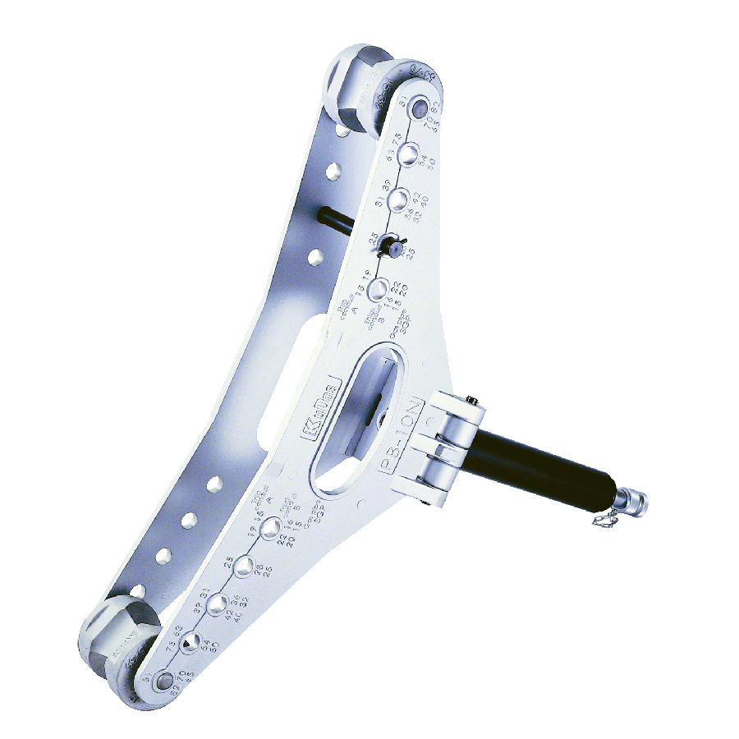
Product Brand | 
Overview Product | Hydraulic Pipe Bender for thin steel condult, thick steel condult and gas pipe
PDF Brosur | https://www.dropbox.com/s/26q66z5g6fshcmu/KuDos_Catalogue.pdf?dl=0
Product Details | - Model No. PB-10N  Length : 780 mm  Weight : 18.6 kgs  ■ Specifications :  Max. pressure : 700 bar  Oil required : 400 cc  Max. output : 12.87 tons / 114.5 kN  Ram stroke : 250 mm  Max. bending : 90 degrees  ■ Bending capacity :  Thin steel conduit : 15 mm-75 mm (5/8”)-(3”)  Thick steel conduit : 16 mm-82 mm (1/2”)(3”)  Gas pipe : 15 mm-65 mm (1/2”)-(2 1⁄2”)  ■ Features :  Compatible with all bending shoes designed to bend JIS standardized conduit pipe and gas pipe.  Designed to bend various sizes and thicknesses of steel pipe.  Makes smooth, wrinkle-free bends.  Bending frame and pivot shoes are lightweight, heat-treated aluminum.  Operated by any hydraulic pump with rated oil pressure of 700 bar (10,000 psi).  The PB-10N was designed to bend various sizes and various thickness of steel pipes without wrinkles.  An aluminum alloy frame makes this bender lighter so that it can be easily carried to the job site.  Bending shoes are designed to bend JIS standardized conduit pipe and gas pipe listed in left chart. If the pipe outer diameter being bent is equivalent to the one from the chart, the shoe can be used for the application.  ■ Accessories :  Aluminum frame  Single action hydraulic cylinder  2 Pivot shoes  ※Remark：Hydraulic pump & bending shoes are sold separately.  ■ Bending shoe :  Thin conduit(A), Thick conduit(B), Gas pipe(SGP)
Key Features | Hydraulic Pipe Bender
Galeri Produk | TERLAMPIR

