Product Title | KuDoS – Hydraulic Pumps
Product Tagline | Professional Electric & Electronic Tool hand Tools
Gambar Utama Produk | 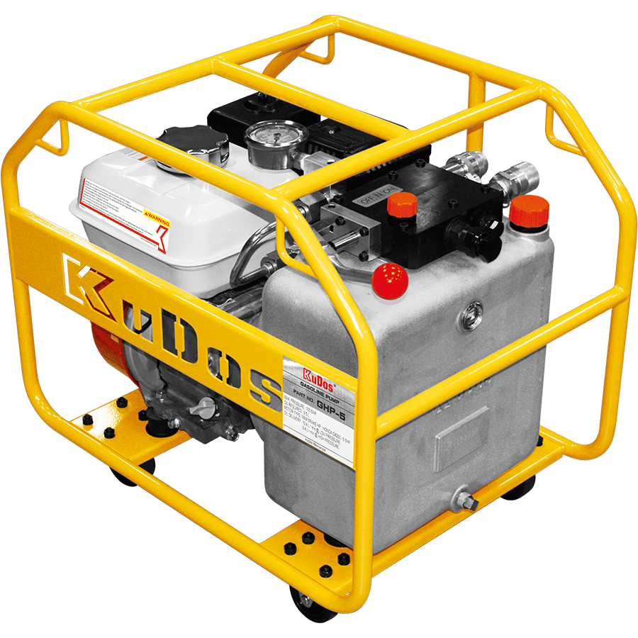
Product Brand | 
Overview Product | Hydraulic Pumps for Crimping Head, Cutting Head, Punching Head, Bender head and Splitting Head
PDF Brosur | https://www.dropbox.com/s/26q66z5g6fshcmu/KuDos_Catalogue.pdf?dl=0
Product Details | - Model No. HP-700A  Hand Pump Series  Length : 595 mm  Weight : 8.8 kgs  ■ Specifications :  Max. pressure : 700 bar  Oil required : 720 cc  ■ Oil delivery :  12.26 cc / stroke at low pressure  2.26 cc / stroke at high pressure  ■ Features :  Dual speed pump piston for rapid advance.  Two stage pumping action.  External adjustable pressure setting up to 700 bar.  Internal oil bladder type oil reservoir allows operation in any position.  Replaceable dropout bypass valve cartridge tor easy rapier.  Economical yet dependable hydraulic foot pump.  ■ Accessories :  2M hydraulic hose attached  - Model No. HYP-700FT  Foot Pump Series  Length : 720 mm  Weight : 13.5 kgs  ■ Specifications :  Max. pressure : 700 bar  Oil required : 1000 cc  ■ Oil delivery :  35.8 cc / stroke at low pressure  2.1 cc / stroke at high pressure  ■ Features :  Dual speed pump piston for rapid advance.  Two stage pumping action.  External adjustable pressure setting up to 700 bar.  Internal oil bladder type oil reservoir allows operation in any position.  Replaceable dropout bypass valve cartridge tor easy repair.  Economical yet dependable foot hydraulic pump.  ■ Accessories :  2M hydraulic hose attached  - Model No. CEP-15SS  Electrical Pump Series  Height : 319 mm  Weight : 8.0 kgs (w/o battery)  ■ Specifications :  Max. pressure : 700 bar  Oil required : 1500 cc  ■ Oil delivery :  1.2 L / min at low pressure  0.3 L / min at high pressure  ■ Features :  Pressure and operation data of date by display function.  Programming switch for crimping, cutting or lifting propose on the panel.  Warning Function: Buzzer alert at long deep if crimping not complete and losing pressure when failure caused.  Display related pumping pressure and battery capacity.  Environmentally design for saving energy as automatic switch to sleep mode after 3 mins without any activate action.  Interior counting function attached  PSI / BAR unit available.  Shoulder strap for high wearing comfort  ■ Accessories :  18V battery 4.0Ah  110V or 230V charger  1M hydraulic hose attached  - Model No. EP-30MD  Electrical Pump Series  Height : 454 mm  Weight : 14.1 kgs (w/o oil)  ■ Specifications :  Max. pressure : 700 bar  Oil required : 3000 cc  4 way, 3 position manual valve  Drive unit : 220V/AC or 110V/AC 50/60Hz  ■ Oil delivery :  2.6 L / min at low pressure  0.32 L / min at high pressure  ■ Features :  With 5 meter remote control cable provides the user complete control to advance and retract.  Two speed high performance.  Pressure holds at 700 bar, ideal for maintenance and construction.  Equipped with large-capacity one piece metal oil tank.  ■ Accessories :  Hydraulic hose should be ordered separately.  - Model No. EP-76SS  Electrical Pump Series  Height : 480 mm  Weight : 26.6 kgs (w/o oil)  ■ Specifications :  Max. pressure : 700 bar  Oil required : 8000 cc  3 way, 2 position manual valve  Drive unit : 220V/AC 100V~120V, 210V~240V, 50/60Hz, 1/2Hp  ■ Oil delivery :  3.9L / min at low pressure  0.2L / min at high pressure  ■ Features :  With 5 meter remote control cable provides the user complete control to advance and retract.  Two speed high performance.  Equipped with single-phase, thermal protected induction motor to reduce noise level.  Pressure holds at 700 bar, ideal for maintenance and construction.  Equipped with large-capacity one piece metal oil tank.  ■ Accessories :  Hydraulic hose should be ordered separately.  - Model No. GHP-5  Engine Pump Series  Height : 590 mm  Weight : 50.5 kgs (w/o oil)  ■ Specifications :  Max. pressure : 700 bar  Oil required : 9.5L  Motor size : 6.5HP  Valve type : 4 way, 3 position  Motor manufacturer : Honda  Manually controlled engine  ■ Oil delivery :  13.4L / min at low pressure  2.4L / min at high pressure  ■ Features :  Pressure gauge can be located in upright position for better reading.  Equipped with a 4 way, 3 position manual valve to prevent the electric control valve being locked and not able to perform retire because of high temperature.  Supplied with a rack with rollers.  High efficiency and fast working gasoline pump.  - Model No. EP-200SD  Engine Pump Series  Height : 691 mm  Weight :78.4 kgs (w/o oil)  ■ Specifications :  Max. pressure : 700 bar  Oil required : 20L  Motor size : 2HP  Valve type : 4 way, 3 position solenoid valve  Input:220V / 230V  ■ Oil delivery :  10.5L / min at low pressure  1.0L / min at high pressure  ■ Features :  With 5 meter remote control cable provides the user complete control to advance and retract.  Easy to use by one button control to advance and retract pumping.  Two stage pumping of high performance.  Equipped with single-phase, thermal protected motor to reduce noise level.  Equipped with large-capacity one piece metal oil tank.
Key Features | Hydraulic Pumps
Galeri Produk | TERLAMPIR

