Brand | 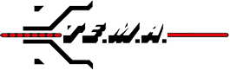
Category | Machine for Tower Erection and Stringing Operation
Sub-Category | Puller-Tensioners
Product Type | AF156.12
Product Tagline | Hydraulic Puller Tensioner 70-75 kN
Gambar Utama Produk | 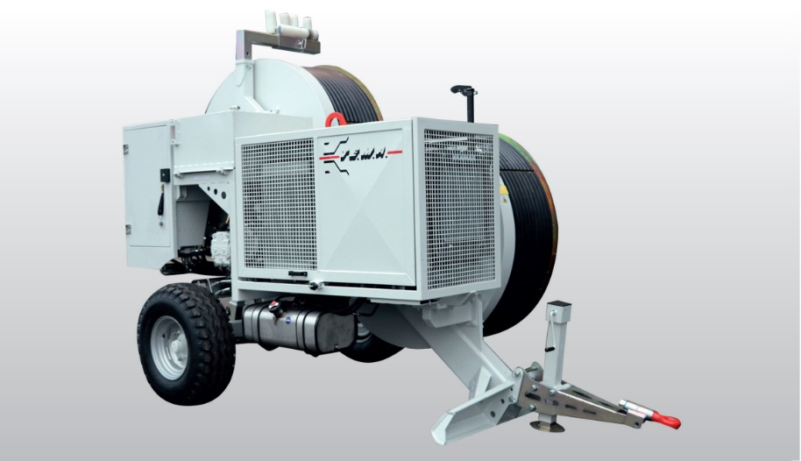
Product Description | Hydraulic Puller-Tensioner 70-75 KN Capacity For Bundle Conductor Stringing Operations
PDF Brosur | https://www.dropbox.com/s/uygdau3ipqj8le5/TEMA_Puller%20Tensioner_AF156.12%20Brochure.pdf?dl=0
Product Details | Puller Performance  Max pull 70 kN  Speed at max pull 1,9 km/h  Max speed 5 km/h  Pull at max speed 26 kN  Tensioner Performance  Max tension 70 kN  Max speed 5 km/h  Characteristics  Adherence-wheels Diameter 1500 mm  Max conductor diameter 40 mm  Max rope diameter 18 mm  Weight 4400 kg  Engine  Diesel (85 Hp) 63 kW  Cooling Liquid  Starter Electrical  Optional Equipment  01-PT Preset for digital data recorder, counter-meter and  speedometer  04-PT Wireless remote control unit c/w console  07-PT Hydraulic power take-off for press  08-PT Conductor/rope holder clamp (hydraulic)  15-PT Adherence wheels with interchangeable Nylon liners  18-PT Multiple connection preset  Special features upon request  02-PT Dynamic speed pulling force control  05-PT Additional hydraulic power take-off on reel-winder circuit  20-PT Pre-heater (up to -30°C)  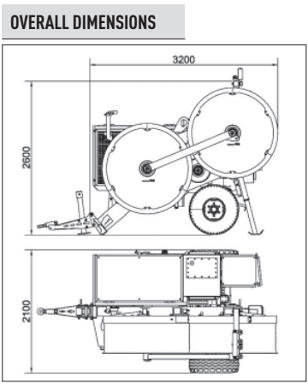
Product Features | Standard features  - 1 hydraulic circuit with negative brake system  - 1 dynamometer for direct reading of pulling value with load-limiter device (puller-mode)  - 1 Counter-meter device  - 2 sets of quick release hydraulic connectors to feed up to 2 remote reel-stands or reel-winder units  - Thermally treated steel adherence wheels  - Gear box (2 speed)  - Wired remote control unit c/w console  - Mechanical stabilizers  - Rigid axle with tyres for towing up to 30 km/h  - Balanced top lifting point and anchoring attachments
Featured Image
Gallery | TERLAMPIR  