Brand | 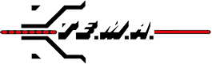
Category | Machine for Tower Erection and Stringing Operation
Sub-Category | Puller-Tensioners
Product Type | AF158.12
Product Tagline | Hydraulic Puller Tensioner 90-95 kN
Gambar Utama Produk | 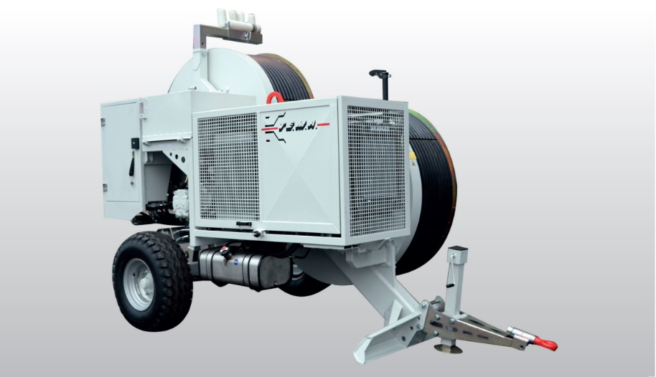
Product Description | Hydraulic Puller-Tensioner 90-95 KN Capacity For Bundle Conductor as Well as OPGW Cable Stringing Operations
PDF Brosur | https://www.dropbox.com/s/90skwq1uxyy6i0a/TEMA_Puller%20Tensioner_AF158.12%20Brochure.pdf?dl=0
Product Details | Puller Performance  Max pull 90 kN  Speed at max pull 2,2 km/h  Max speed 5 km/h  Pull at max speed 40 kN  Tensioner Performance  Max tension 90 kN  Max speed 5 km/h  Characteristics  Adherence-wheels Diameter 1500 mm  Max conductor diameter 40 mm  Max rope diameter 24 mm  Weight 5000 kg  Engine  Diesel (125 Hp) 93 kW  Cooling Liquid  Starter Electrical  Optional Equipment  01-PT Preset for digital data recorder, counter-meter and  speedometer  04-PT Wireless remote control unit c/w console  07-PT Hydraulic power take-off for press  08-PT Conductor/rope holder clamp (hydraulic)  15-PT Adherence wheels with interchangeable Nylon liners  18-PT Multiple connection preset  Special features upon request  02-PT Dynamic speed pulling force control  05-PT Additional hydraulic power take-off on reel-winder circuit  20-PT Pre-heater (up to -30°C)  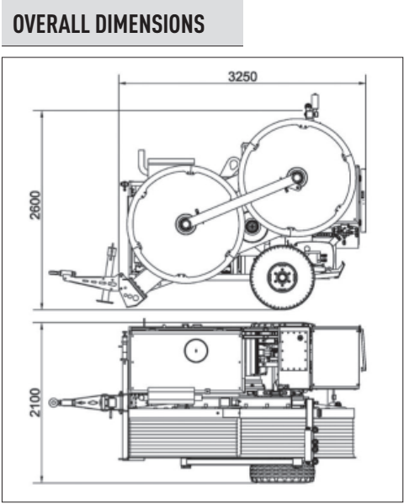
Product Features | Standard features  - 1 hydraulic circuit with negative brake system  - 1 dynamometer for direct reading of pulling value with load-limiter  device (puller-mode)  - 1 Counter-meter device  - 2 sets of quick-release hydraulic connectors to drive up to 2  hydraulic driven reel-stands or reel-winder units  - Thermally treated steel adherence wheels  - Gear box (2 speed)  - Wired remote control unit c/w console  - Hydraulic stabilizers  - Rigid axle with tyres for towing up to 30 km/h  - Balanced top lifting point and anchoring attachments
Featured Image
Gallery | TERLAMPIR  