Brand | 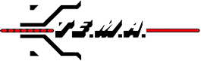
Category | Machine for Tower Erection and Stringing Operation
Sub-Category | Hydraulic Puller
Product Type | 107R8
Product Tagline | Hydraulic Puller Underground 90-95 KN
Gambar Utama Produk | 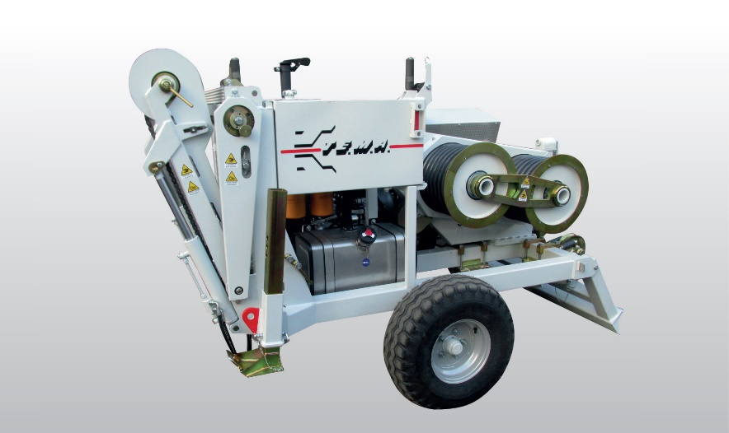
Product Description | Hydraulic Puller 90 KN Capacity For Single Rope Pulling On Overhead Stringing Operations As Well As Underground Cabling.
PDF Brosur | https://www.dropbox.com/s/ehtdlcd9lsx14xg/TEMA_Puller%20Underground_107R8%20Brochure.pdf?dl=0
Product Details | Puller Performance  Max pull 90 kN  Speed at max pull 2 km/h  Max speed 5 km/h  Pull at max speed 36 kN  Characteristics  Adherence-wheels Diameter 600 mm  Max rope diameter 24 mm  Weight 3400 kg  Engine  Diesel (125 Hp) 93 kW  Cooling Liquid  Starter Electrical  Optional Equipment  01-PW Preset for digital data recorder, counter-meter  and speedometer  04-PW Wireless remote control unit c/w console  05-PW Rope holder clamp (hydraulic)  06-PW Roller guiding device for Underground laying  07-PW Hydraulic power take-off for remote reel-winder  Special features upon request  13-PW Pre-heater (up to -30°C)  18-PW Counter-meter device  20-PW Dynamic speed pulling force control  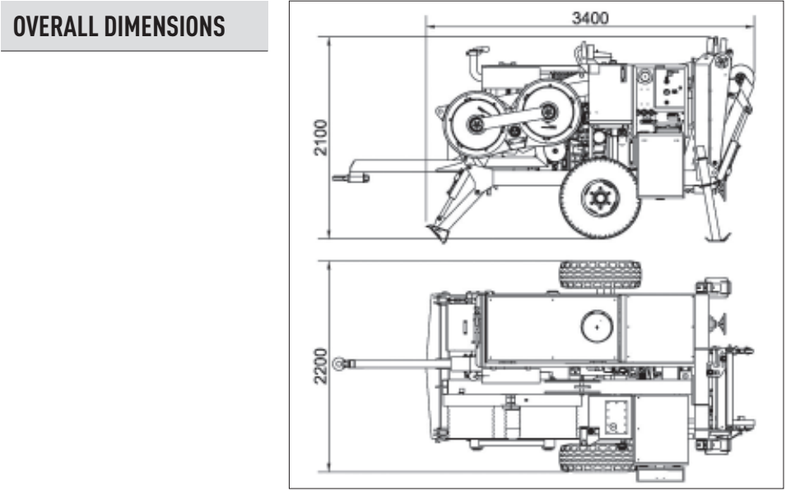
Product Features | Standard features  - 1 hydraulic circuit with negative brake system  - 1 dynamometer for direct reading of pulling value  with load-limiter device  - Thermally treated steel bull-wheels  - Automatic reel-winder suitable for steel reel 1100÷1400 mm  - Wired remote control unit c/w console  - Rigid axle with tyres for towing up to 30 km/h  - Balanced top lifting point and anchoring attachements
Featured Image | 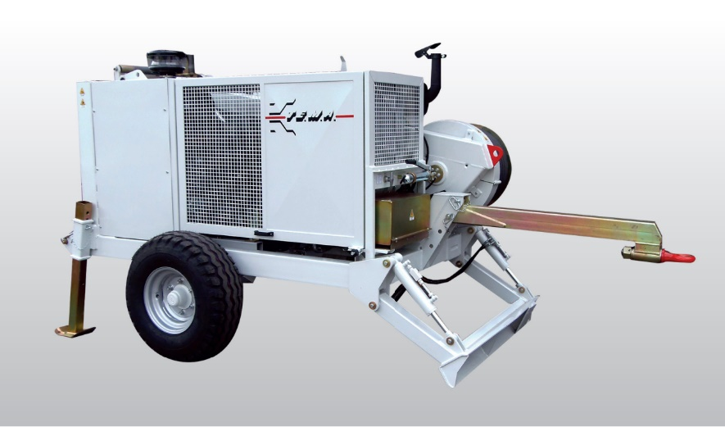
Gallery | TERLAMPIR  